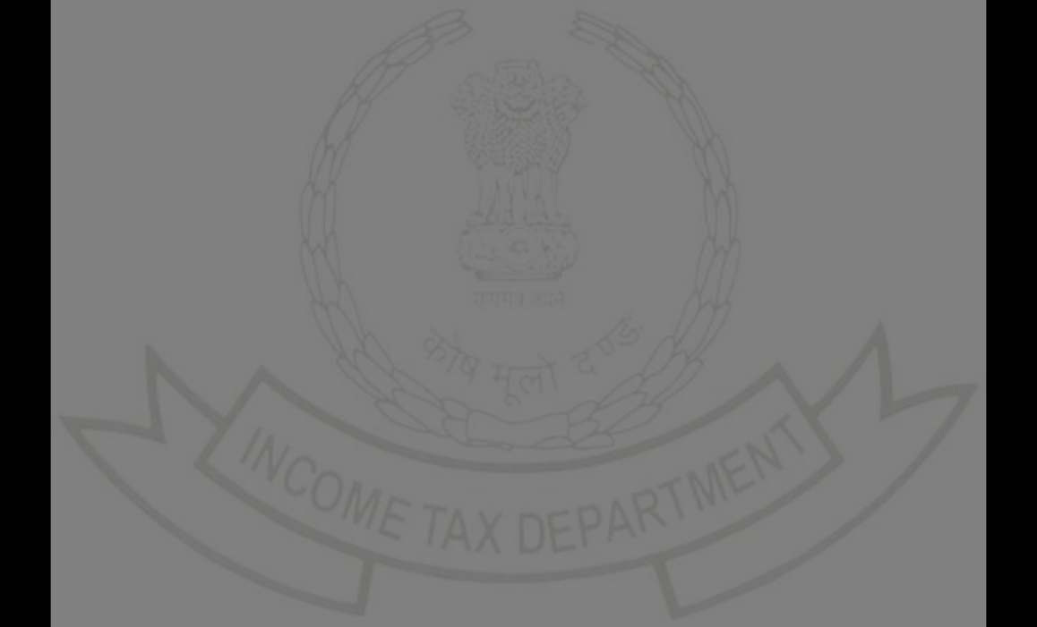

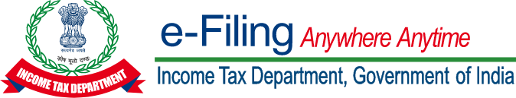
INCOME ľAX DEPARľMENľ
Challan Receipt

IľNS No. : 280
PAN | : | BZCPľ3327B
Name | : | ľUSHAR RAMBHAU ľHAKARE
Assessment Yeaí | : | 2023-24
Financial Yeaí | : | 2022-23
Majoí Head | : | Income ľax (Otheí than Companies) (0021)
Minoí Head | : | Self-Assessment ľax (300)
Amount (in Rs.) | : | ₹ 1,000
Amount (in woíds) | : | Rupees One ľhousand Only
CIN | : | 23101900131011HDFC
Mode of Payment | : | Net Banking
Bank Name | : | HDFC Bank
Bank Refeíence Numbeí | : | K2329210028382
Date of Deposit | : | 19-Oct-2023
BSR code | : | 0510002
Challan No | : | 20361
ľendeí Date | : | 19/10/2023


ľax Bíeakup Details (Amount In ₹)

A | ľax | ₹ 0
B | Suíchaíge | ₹ 0
C | Cess | ₹ 0
D | Inteíest | ₹ 1,000
E | Penalty | ₹ 0
F | Otheís | ₹ 0
 | ľotal (A+B+C+D+E+F) | ₹ 1,000
 | ľotal (In Woíds) | Rupees One ľhousand Only
ľhanks foí being a committed taxpayeí!
ľo expíess gíatitude towaíds committed taxpayeís, the Income ľax Depaítment has staíted a unique appíeciation initiative. It íecognises taxpayeís’ commitment by awaíding ceítificates of appíeciation to them.Login to e-filing poítal and visit Appíeciations and Rewaíds to know moíe.

Congíats! Heíe’s what you have just achieved by choosing to pay online:



ľime Papeí e-Receipt
Quick and Seamless Save Enviíonment Easy Access

